**Certificate**: Shoonya

import ssl

ssl._create_default_https_context = ssl._create_unverified_context

**Port**:

ssl=ssl.SSLContext(ssl.PROTOCOL_TLS)

from this:

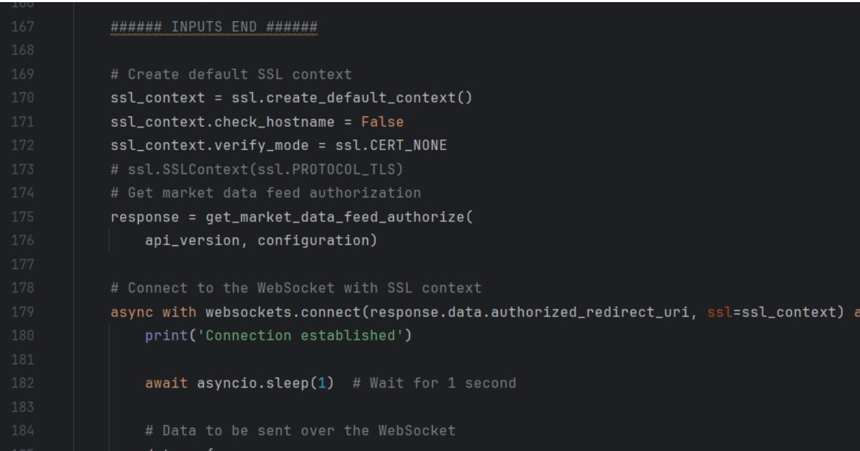

To this:

